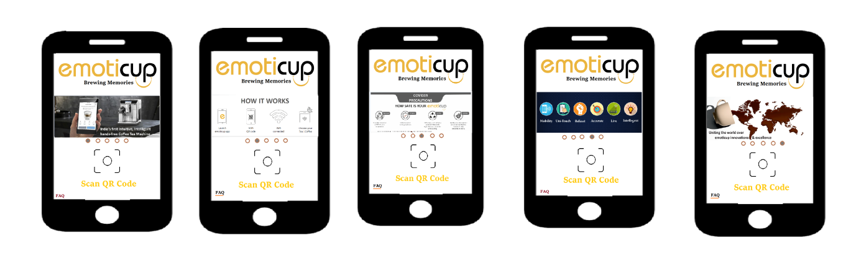

**5 wallpapers on the main screen**

* All 5 wallpapers will be attached in the same order as shown above.
* FAQ’s will be on the left corner, on one touch the list of Questions will open with answers.
* On one touch for QR code icon then the scanning screen will open & Start scanning.
* Once we scan the appropriate QR code WIFI connects automatically to the machine network as it is working now.
* After Scanning the menu will be shown for 15secs to select any options.
* After choosing one option in the menu then it will show the same icon which is chosen in the next page with Force Stop option.
* Then all other options will be disabled except one which is selected.
* Every user can select the option only once for one scan.
* The screen should not have backlash to the menu screen.
* If Wi-Fi can’t connect then error message should come like Try again.
* The next screen will be occupied for 12 secs with force stop option.
* Once user press the force stop then the screen will be back to home page one by showing the thank you in the next page for 2secs.
* After completion of the 12 secs the page will show thank you for 2 secs and then it will be back to main menu home page automatically.
* Fallow the order of the menu shown in the picture with the icons given with the resolution required.
* Make the background black in the menu screen.

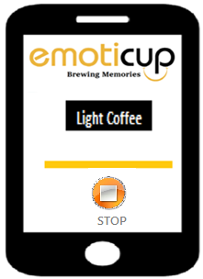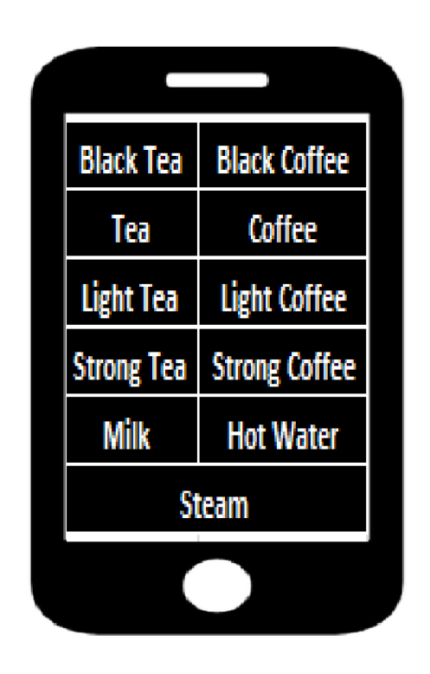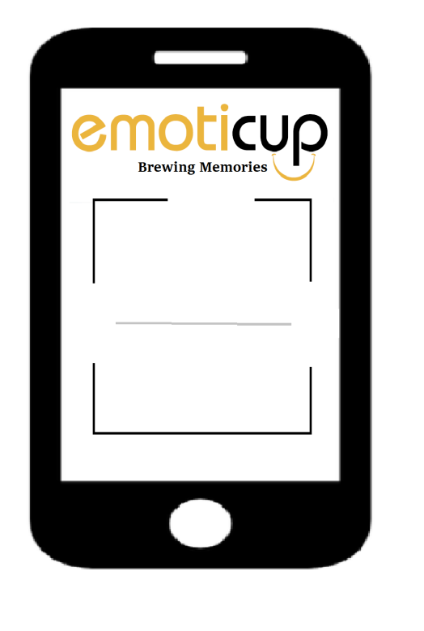

**15 secs**

**12secs**

**Menu page**

**option page**

**Scan page**



**Thank you Page**

**2 secs**